|  |  |
| --- | --- |
| http://images.8tracks.com/cover/i/001/358/131/7357.original-3735.jpg?rect=0,29,289,289&q=98&fm=jpg&fit=max&w=100&h=100 | ***Serious exercises*** |

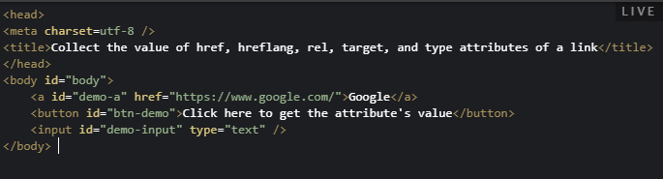

1. Follow HTML:

Write a JavaScript code to get the value of the href specified link (<a></a>) send display it in the input field xwhen clicking on the button.

Demo (after click):



1. Research the **<select></select>, <option></option>** tags in HTML and create a dropdown list as below:

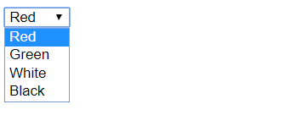

Create the button beside the dropdown list.

Write a JavaScript program to remove selected item from a dropdown list when clicking on the button.

1. **(OPTIONAL)** Research the **<table></table>, <tr></tr>, <td></td>** tags in HTML and create a table as follow

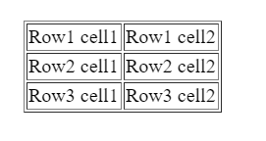

Create the button below the table.

Write a JavaScript program allows users insert 3 things from the keyboard:

* Row number
* Column number
* Content

And update the new content of selected cell (based on row number and column number) when users click on the button.